Little SPARK: Simple Play Adaptations to Reference for Kids

Giant Sea Life Stampers Set
Description: | Image:
These 10 stamps include familiar sea creatures. Each 3" diameter stamp features an easy grip handle, with see-thru top for easy placement. Warning: Choking Hazard - Small Parts. Not for children under 3 years. | 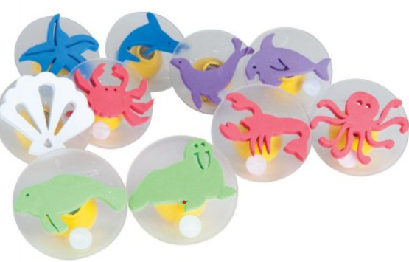

Who Might Benefit?
Those who have trouble holding writing tools, experience motor challenges that interfere with combining strokes and figures, and show interest in “drawing” or creating artwork.

Why Use?
Provides an opportunity to create artwork and participate in “drawing” without needing to control a pencil, crayon, or paint brush.
Instructions for Use: | Adaptation Ideas:
Environmental Considerations  - Consider a designated area for stamping with ink or paint which might include an easy to clean mat or a cookie sheet.  Positioning & Alternate Positioning  - Use in any position; seated, standing, on the floor, with a slanted surface, vertical plane or any solid, flat surface.  Basic Play/Use  - Provide ink or paint, paper and stamps and allow children to create then talk about it.  Extended Play/Use  - Provide laminated cards with matching pictures or a scene to match stamps.  Play/Use with Others  - Pair children and show them how to form a Tic Tac Toe Grid on paper. Encourage them to choose a stamp to play. | Build It Up  - Build up stamp handles with Wikki Stix or rubber bands.  Simplify It  - Offer only a few stamps at a time.  Stabilize It  - Tape down paper that the child is stamping or clamp it onto an easel.  Contain It  - Place paper, paint, ink pads and stamps on a rimmed cookie sheet or box lid.  Add Sensory Cues  - Add textures to the handles of the stamps.  Communication Support  - Provide a paper-based communication board with activity related words.  DIY Alternatives  - During outdoor play use stamp with water on a painted surface and watch it “disappear” as the water marks evaporate.

Words to Encourage Play/Use
Pick  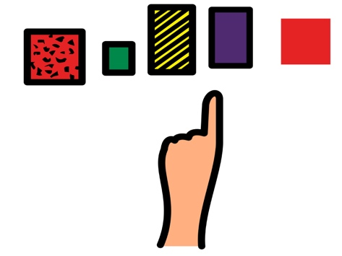 | Find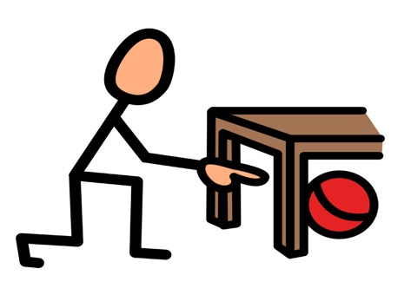 | Push 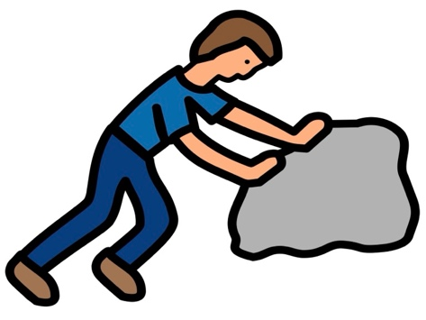
Hold | Ready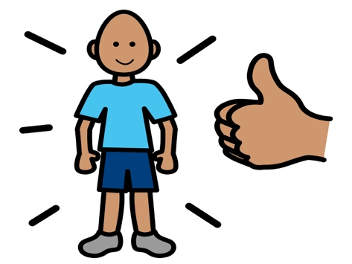 | Help 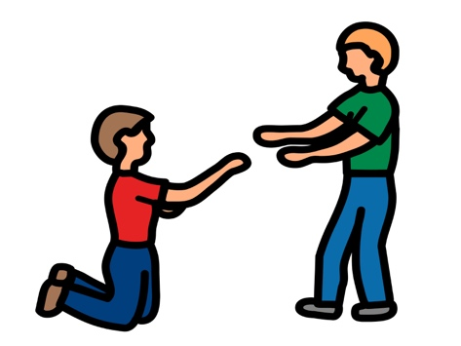
More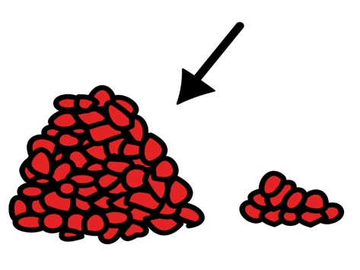 | Done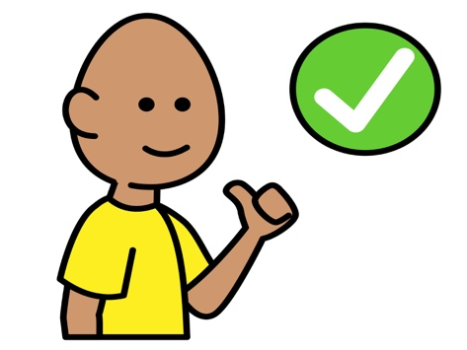 | Share  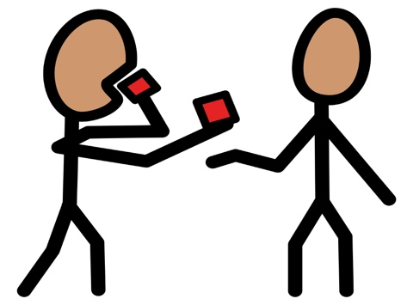
*”Adaptations” adapted from: Haugen’s Modes for Adapting Toys based on materials from the "Let's Play" Project at the University of Buffalo
PCS is a trademark of Tobii Dynavox, LLC. All rights reserved. Used with permission.

